# Preface

The document describes the procedure for creating user administration in TIA Unified HMI.

# Compatibility

TIA Portal V19

TIA Unified HMI V19

# Import Control Module Library

# Create User-Specific runtime rights

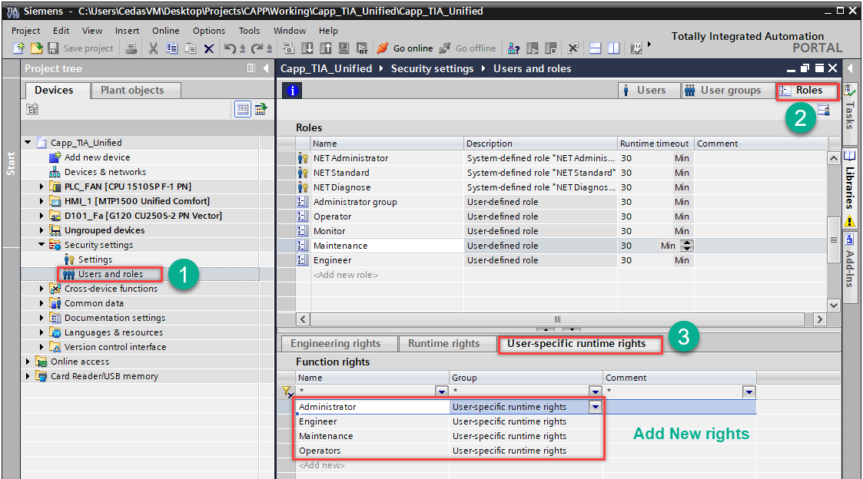

# Create Roles and assign Function rights

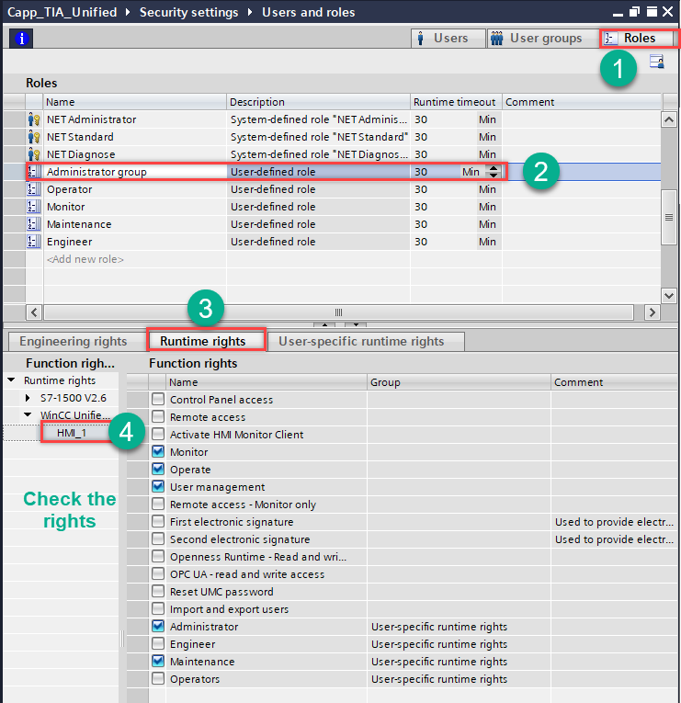

# Create Users and Assign roles

User levels are divided into the five user groups below. Find passwords related to the listed users.

|  |  |  |  |  |  |  |
| --- | --- | --- | --- | --- | --- | --- |
|  | Siemens Predefined access |  | Operate | Remote access | User Management |  |
|  | User defined access |  |  |  | Administrator | Engineer |
|  | **Username** | **Password** |  |  |  |  |
| 1 | Operator | Operator123 | Yes | No | No | No |
| 2 | Maintenance | Maint123 | Yes | Yes | No | No |
| 3 | Admin | Admin123 | Yes | Yes | Yes | No |
| 4 | SuperAdmin | [Admin@123](mailto:Cedas@123) | Yes | Yes | Yes | Yes |

Each action on the HMI screens is configured with various access levels. The assigned codes are cross-referenced with the table above to determine the rights of the logged-in user.

**For Anonymous user: don’t give any access rights**

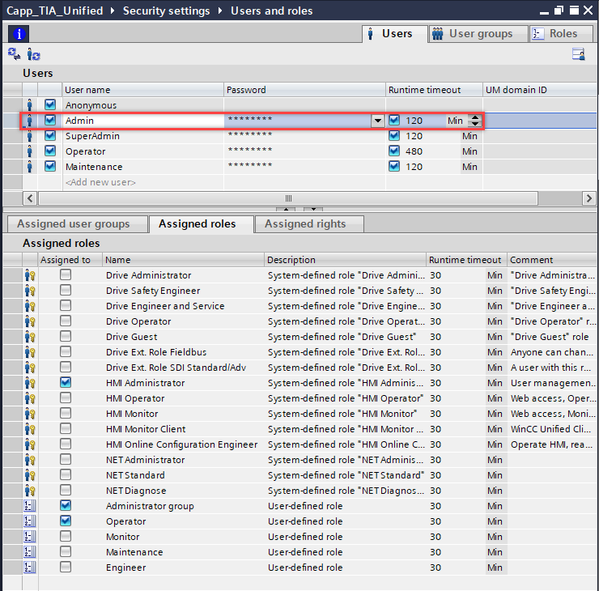

# User Access Level

User access is configured based on the category of the logged-in user. Each user is assigned different access levels, which are classified with codes A through K. Below is a table detailing these access levels.

|  |  |  |  |  |  |  |
| --- | --- | --- | --- | --- | --- | --- |
|  | login duration |  | 8hrs | 2hrs | 2hrs | 2hrs |
| **Code** | **Access** | **Default** | **Operators** | **Maintenance** | **Administrator** | **Engineer** |
| A | Start/Stop Machine, Jog Conveyor, Home Sequence | No | Yes | Yes | Yes | Yes |
| B | Acknowledge of alarms | No | Yes | Yes | Yes | Yes |
| C | Load recipe data | No | Yes | Yes | Yes | Yes |
| D | Change setpoints /recipe values/ Activation time/-delay + Activate Auto reset | No | No | Yes | Yes | Yes |
| E | Change between Auto- / Manual mode | No | No | Yes | Yes | Yes |
| F | Motor Jog activation | No | No | Yes | Yes | Yes |
| G | Reset counter | No | No | Yes | Yes | Yes |
| H | Activate Ignore button | No | No | Yes | Yes | Yes |
| I | Motor Acc- / Dec- time, Digital Sensor Act/DAct Delay | No | No | No | Yes | Yes |
| J | Edit System settings | No | No | No | Yes | Yes |
| K | Advanced machine builder and developer actions and settings | No | No | No | No | Yes |

### AIN - Faceplate

